Shareable Link Observations:

- Spelling mistake in Create Shareable Link pop up.

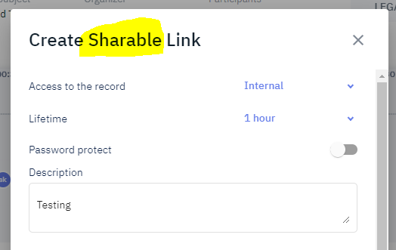
- Tab functionality not working in “Create shareable Link” popup.

Steps: Open the popup shareable Click Tab and Observe .
Example: in share Via email box enter one emailid and click on tab observe.

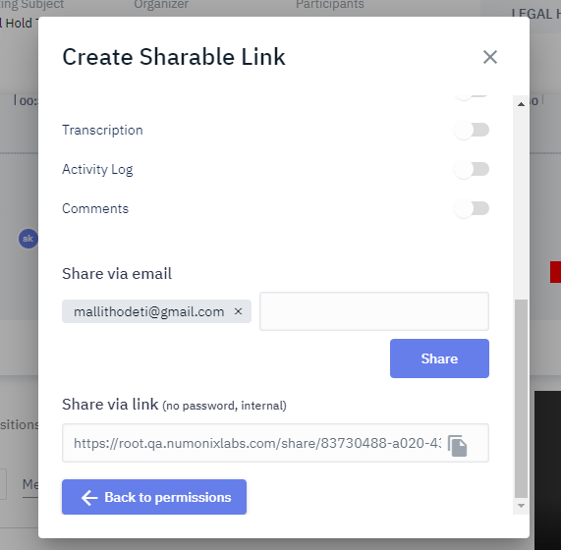

- Once successfully Share the link popup need to be close but pop is not closed.
- Unable to edit the Description once we will click on create the share link.

We may not allow to edit the password but we should allow to edit description.

Steps:
- Open “Create Shareable link” popup
- Select the Access the record and Life Time
- Enter password and Description than click on Create Link
- Than Try to edit the “ Description” or Password.

